Name_________________________________ Period _____________ Date ________________



**Lesson 4: You Draw It-2**

In Lesson 1 you solved a problem with three fueling stations using a simulation. Now, have you learned enough to complete the process on your own without the help of a computer? Get out your pencil and sharpen your brain to solve a new problem.

**Doing the Science**

1. You do *not* need a computer to complete this lesson.

2. Your teacher will provide you with the location of each of the three existing fueling stations. Record these locations in Table 1. Using the gridded map below (Figure 1), draw and label points on the map representing each of the three stations.

3. Using only your paper, pencil and a ruler, find the best location of the new fueling station. Record this location in Table 1.

**Table 1. Fueling Stations’ Locations**

|  |  |
| --- | --- |
| **Fueling Station’s Letter** | **Location** |
|  |  |
|  |  |
|  |  |
| **New Fueling Station** |  |

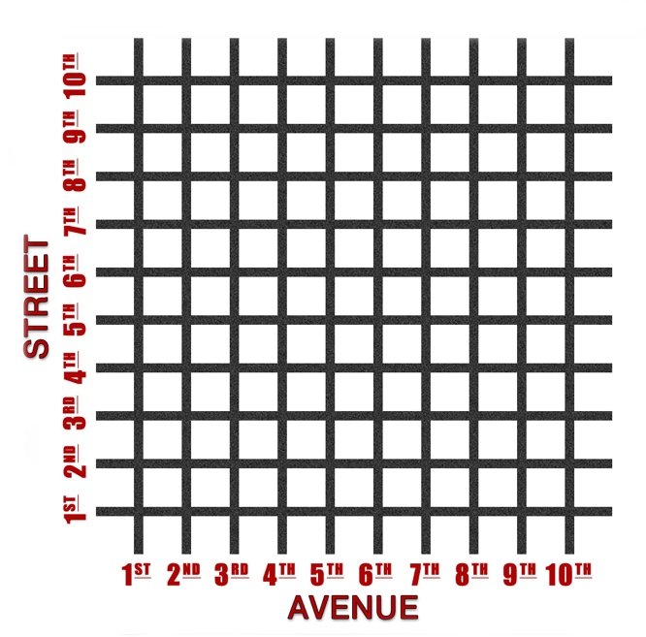**Figure 1.**

**Do You Understand?**

1. Describe how you arrived at the best location of the new fueling station.

2. Describe how this task differed from the one you completed in Lesson 1.